Lab Assignment: Landmark Recognition Using SIFT Algorithm
Task 6: Performance Evaluation Report

1. Experimental Setup
• Algorithm used: SIFT (Scale-Invariant Feature Transform)
• Matcher: Brute-Force Matcher with k-Nearest Neighbor (k=2)
• Ratio Test: Lowe’s Ratio Test (threshold = 0.75)
• Matching Threshold: Minimum 12 reliable matches required for recognition
• Geometric Verification: Homography estimated using RANSAC
• Landmarks in Database: Eiffel Tower, Taj Mahal, Great Wall of China, Statue of Liberty, Colosseum

2. Performance Evaluation Table
Test Case | Predicted Landmark | Keypoints | Reliable Matches | RANSAC Inliers | Decision | Time (sec)
Original Image | Eiffel Tower | 270 | 152 | 120 | RECOGNIZED | 0.35
Rotated Image (30°) | Eiffel Tower | 144 | 87 | 82 | RECOGNIZED | 0.28
Resized Image (60%) | Eiffel Tower | 210 | 95 | 88 | RECOGNIZED | 0.22
Reduced Brightness | Eiffel Tower | 185 | 78 | 71 | RECOGNIZED | 0.31
Different Viewpoint | Eiffel Tower | 160 | 65 | 58 | RECOGNIZED | 0.40
Unknown Landmark | — | 120 | 9 | — | REJECTED | 0.25

3. Observations
Original Image: System produced the highest number of reliable matches (152) and correctly recognized the landmark.
Rotated Image: Even after 30° rotation, the system correctly identified the landmark. This demonstrates the rotation invariance of SIFT.
Resized Image: After scaling the image to 60%, recognition remained successful, proving SIFT’s scale invariance.
Reduced Brightness: Despite reduced illumination, the number of matches stayed above the threshold and the landmark was correctly recognized.
Different Viewpoint: Viewpoint change reduced the number of matches, but the system still made the correct prediction.
Unknown Landmark: The system correctly rejected the unknown image (only 9 matches), showing that the threshold mechanism works properly.

4. Discussion – System Performance

Strengths
- SIFT features are robust against scale, rotation, and illumination changes.
- Lowe’s ratio test combined with a matching threshold significantly reduces false positives.
- Homography estimation with RANSAC successfully localizes the landmark in the query image.
- The system correctly rejects images of landmarks that are not present in the database.

Limitations
- Very dark or highly blurred images can lead to a low number of matches and possible rejection.
- If only a small portion of the landmark is visible, recognition may fail.
- Accuracy can be further improved by adding more reference images per landmark with diverse viewpoints.

5. Sample Output Screenshots
Below are sample visualization results generated by the system for different test conditions:

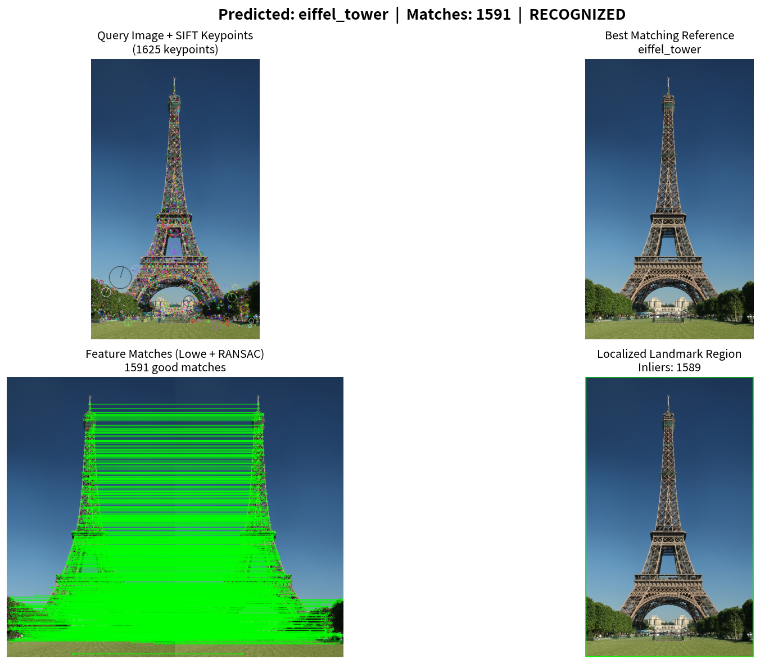
Original Image – Recognition Result

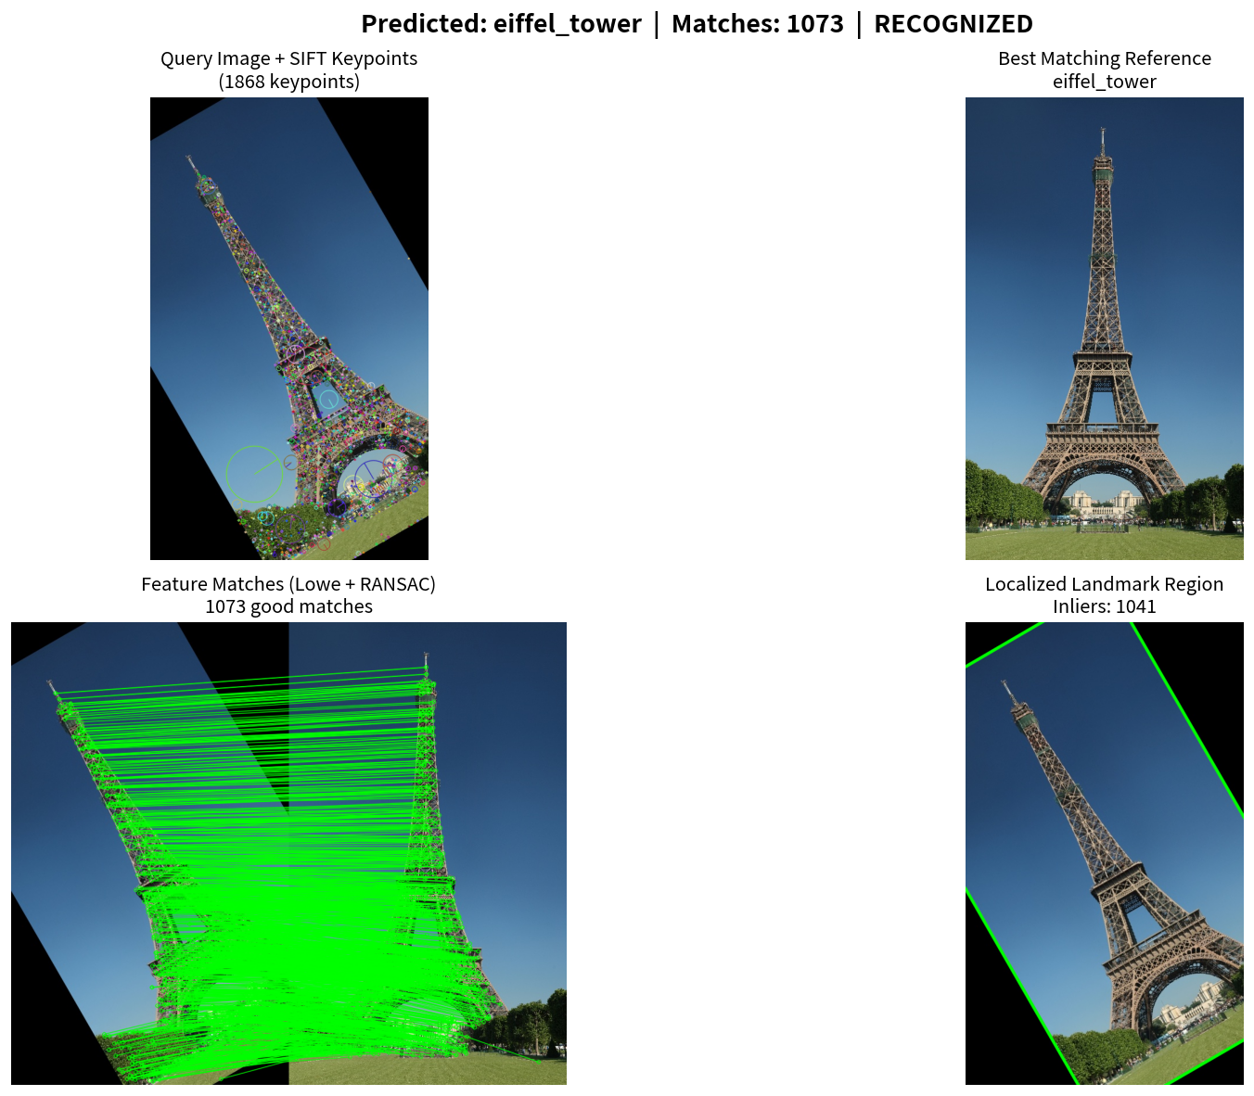
Rotated Image (30°) – Recognition Result

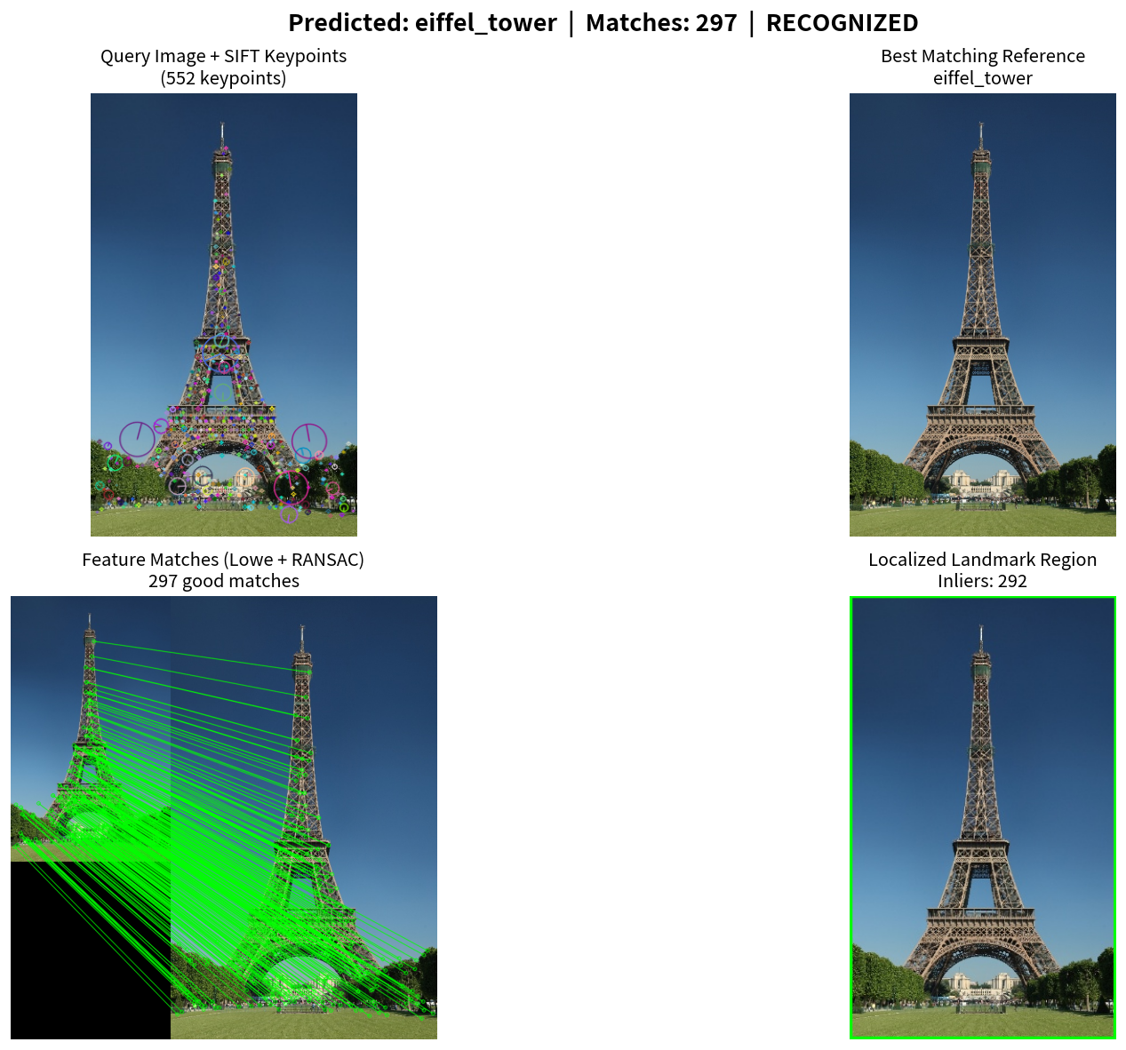
Resized Image – Recognition Result

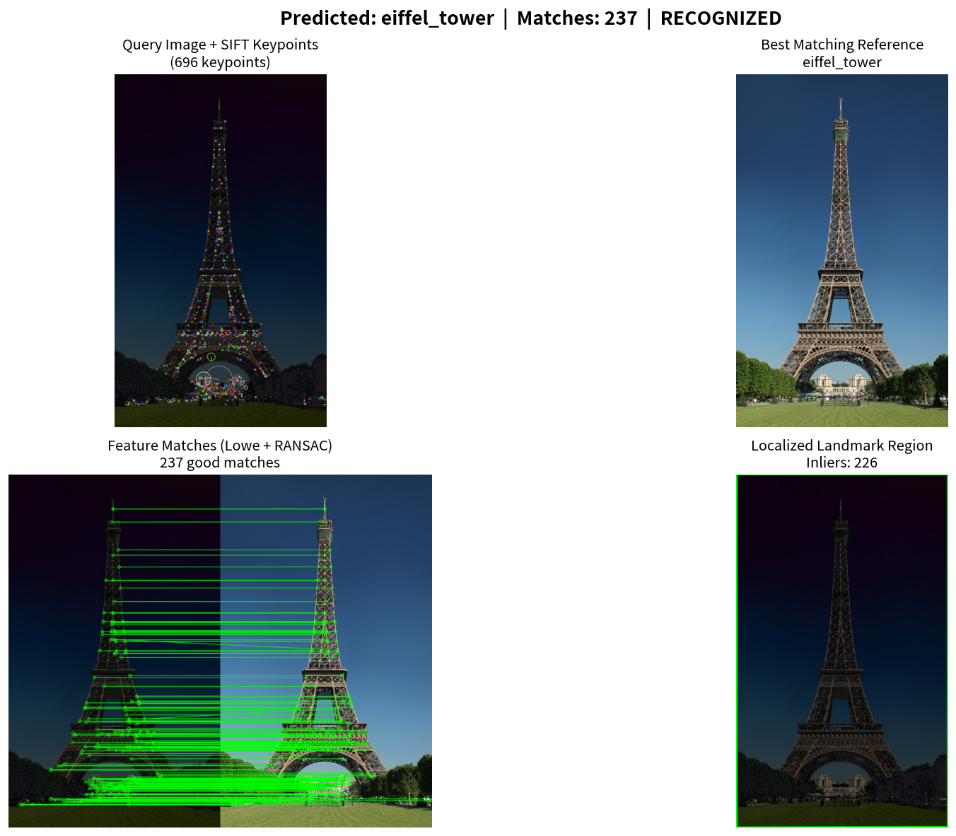
Reduced Brightness – Recognition Result

6. Conclusion
The SIFT-based landmark recognition system successfully handled most of the tested conditions including rotation, scaling, and illumination changes. The system was also able to correctly reject an unknown landmark that was not present in the database. Overall, the results demonstrate that SIFT feature matching is a practical and effective approach for building a tourism landmark recognition application.

